This is a strong final-year project idea because it addresses a real healthcare problem while combining Artificial Intelligence, Medical Imaging, Explainable AI, and Web Development. However, to make it research-worthy, the key is not just detecting spondylolisthesis, but solving a problem that existing research doesn't solve well.

Proposed Project
Title (Initial)
AI-Powered Clinical Decision Support System for Automated Spine X-ray Analysis and Surgical Recommendation
or
SpineAI: Explainable Deep Learning System for Lumbar Spine Disorder Detection and Clinical Decision Support
The project consists of
Patient uploads

↓

X-ray / PDF

↓

Image Extraction

↓

AI Model

↓

Detect vertebrae

↓

Measure alignment

↓

Identify disease

↓

Severity Grade

↓

Need Surgery?

↓

Explain WHY

↓

Generate Report

↓

Doctor Dashboard
Notice that "Need Surgery?" should be framed as a clinical recommendation or risk assessment, not a definitive decision. Surgery depends on symptoms, neurological findings, MRI, patient history, and specialist evaluation—not just an X-ray.

Understanding the Spine
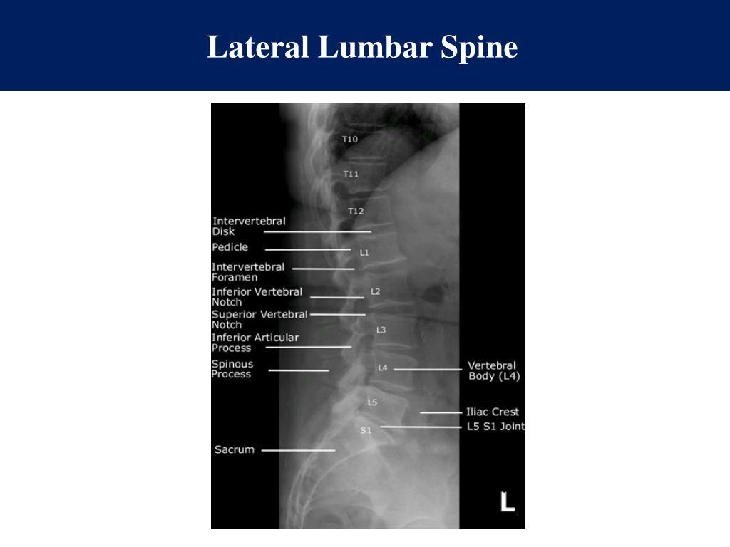
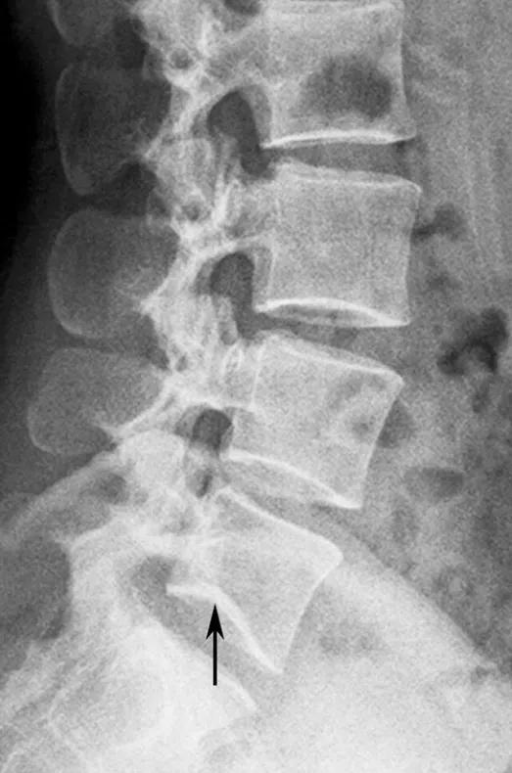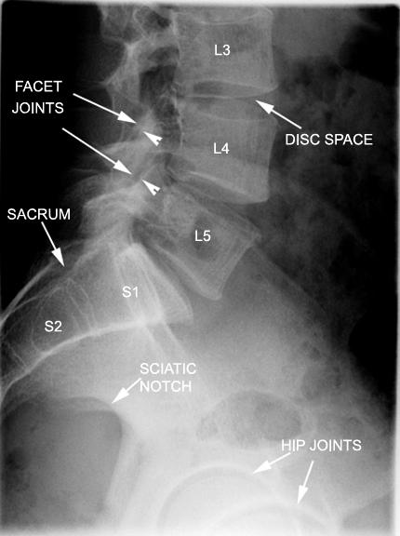

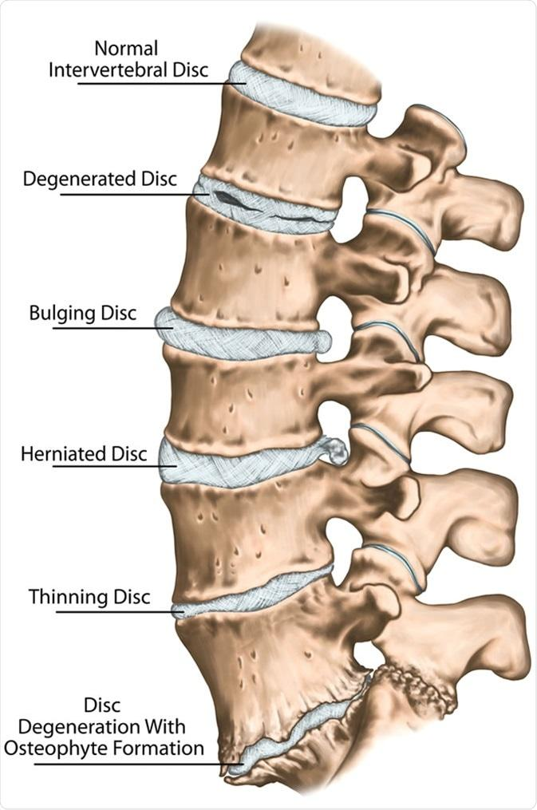
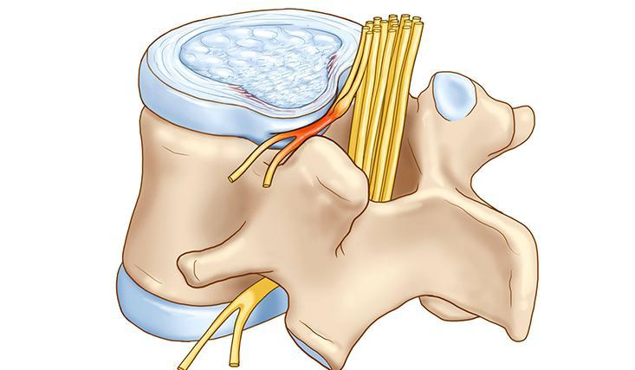
The human spine contains
- Cervical (Neck)
- Thoracic (Chest)
- Lumbar (Lower Back)
- Sacrum
- Coccyx
Most spinal disorders occur in
Lumbar Spine (L1-L5)
because it bears body weight.

Important Vertebrae
L1

L2

L3

L4

L5

S1
The most common disease
L5 slips over S1
This is called

Spondylolisthesis

What is Spondylolisthesis?
Instead of staying aligned,
Normal

L4
██████

L5
██████

Abnormal

L4
██████

██████
L5
One vertebra moves forward.
This causes
- lower back pain
- leg pain
- numbness
- weakness
- difficulty walking

Types

Degenerative
Most common
Age
40+

Isthmic
Stress fracture
Young athletes

Congenital
Birth defect

Traumatic
Accident

Pathological
Tumor/Infection

Severity (Meyerding Grading)
Grade I

0–25%

Grade II

26–50%

Grade III

51–75%

Grade IV

76–100%

Grade V

Complete slip
This grading is very important.
Instead of only saying
Disease Found
your AI can say
Grade II Degenerative Spondylolisthesis
This is clinically much more useful.

Other Diseases Detectable from X-rays
Besides spondylolisthesis:

Disc Space Narrowing
Reduced gap
██████

------

██████
Suggests
- Degenerative Disc Disease
- Disc degeneration

Scoliosis
Curved spine

Compression Fracture
Collapsed vertebra

Osteophytes
Bone spurs

Spondylolysis
Stress fracture
Often causes spondylolisthesis.

Osteoporosis signs
Low bone density

Vertebral collapse

Lumbar instability

Degenerative changes

Can X-rays alone determine surgery?
No.
An X-ray can suggest severity and structural problems, but surgery decisions usually require:
- MRI findings
- Neurological examination
- Pain severity
- Functional impairment
- Duration of symptoms
- Response to conservative treatment
So your system should output something like:
- "Low likelihood of surgical referral"
- "Recommend orthopedic/spine specialist evaluation"
- "Imaging suggests features commonly associated with surgical assessment"
rather than "Operation required."

Your AI Pipeline
PDF/X-ray

↓

Image enhancement

↓

Preprocessing

↓

Spine Detection

↓

Vertebra Detection

↓

Segmentation

↓

Landmark Detection

↓

Measurements

↓

Disease Classification

↓

Severity

↓

Clinical Recommendation

↓

Explainable AI

↓

Report

AI Models
Different stages can use different models.

Stage 1
Object Detection
Examples:
- YOLOv11
- RT-DETR
Detect
L1

L2

L3

L4

L5

S1

Stage 2
Segmentation
Models
- U-Net
- Attention U-Net
- nnU-Net
- Mask R-CNN

Stage 3
Landmark Detection
Find vertebral corners
Measure
- slip %
- disc height
- vertebral angle

Stage 4
Classification
CNN
Examples
- EfficientNet
- DenseNet121
- ResNet50
- ConvNeXt

Stage 5
Explainability
Very important.
Use
- Grad-CAM
- Score-CAM
- SHAP
- Integrated Gradients
Doctors want
Why?
not only
Positive

Technology Stack
Frontend
- React
- Next.js
Backend
- FastAPI
Model
- PyTorch
Database
- PostgreSQL
Storage
- Firebase Storage / AWS S3
Deployment
- Docker
GPU
- Google Colab
- Kaggle
- Paperspace

Data Required
Need
Thousands of
- Lumbar X-rays
- Lateral View
- AP View
Annotations
Bounding Box

Segmentation

Disease

Grade

Disc Space

Slip %

Public Datasets to Explore
Several publicly available spine imaging datasets can support parts of this project, including:
- Lumbar spine X-ray datasets with vertebral landmarks or segmentation
- Datasets released for vertebral compression fracture detection
- SpineWeb collections (research community)
- Mendeley Data spine image datasets
- Kaggle lumbar spine datasets (quality varies)
- Open datasets associated with lumbar MRI challenges (useful for future expansion)
A challenge is that fully labeled X-ray datasets with surgical labels are rare, so you may need to combine datasets or work with clinician annotations.

Website Features
Patient
- Upload PDF
- Upload X-ray
- History
Doctor
- Dashboard
- Compare scans
- Explain AI prediction
- Annotate
- Correct AI
Admin
- Dataset management
- Model retraining
- Analytics

PDF Handling
Many hospitals provide reports as PDF.
Pipeline
PDF

↓

Extract Images

↓

Image Enhancement

↓

Run AI

↓

Generate New Report

Report
Instead of
Positive
Generate
Patient ID

Image Quality

Detected Disease

Affected Vertebra

Slip %

Grade

Disc Height

Confidence

Heatmap

Recommendation

Doctor Notes

Research Gaps
This is where your project can stand out.
Many published systems:
- detect only one disease,
- provide only a classification label,
- don't explain the prediction,
- don't estimate severity,
- don't integrate into a usable web platform,
- aren't designed for clinical workflows.
Potential research contributions include:
- One system that detects multiple lumbar conditions from X-rays.
- Automatic vertebral measurements (e.g., slip percentage, disc height).
- Explainable AI visualizations to support clinician trust.
- Structured clinical decision support rather than a simple "positive/negative" result.
- PDF-to-report automation.
- A doctor feedback mechanism so corrected labels can improve future model versions.

Research Papers to Start With
The following highly influential papers and model families are worth studying because they form the foundation of modern medical image AI:

Deep Learning
- ImageNet Classification with Deep Convolutional Neural Networks (AlexNet) (2012)
- Deep Residual Learning for Image Recognition (ResNet) (2015)
- DenseNet: Densely Connected Convolutional Networks (2017)
- EfficientNet: Rethinking Model Scaling for CNNs (2019)

Medical Imaging
- U-Net: Convolutional Networks for Biomedical Image Segmentation (2015)
- Attention U-Net (2018)
- nnU-Net (2021)

Explainable AI
- Grad-CAM: Visual Explanations from Deep Networks via Gradient-based Localization (2017)
- Score-CAM (2020)
- SHAP: A Unified Approach to Interpreting Model Predictions (2017)

Spine-Specific Topics
Search for combinations such as:
- "lumbar spine X-ray deep learning spondylolisthesis"
- "vertebral landmark detection lumbar radiographs"
- "automatic Meyerding grading using deep learning"
- "lumbar spine segmentation X-ray"
- "vertebral slip measurement AI"
These searches will surface the most relevant and frequently cited spine-specific work.

Expected Challenges
- Finding sufficiently large, high-quality annotated X-ray datasets.
- Variability in image quality, patient positioning, and imaging equipment.
- Distinguishing subtle degenerative changes from normal aging.
- Building a recommendation system that is clinically responsible and clearly communicates its limitations.
- Validating the model with appropriate metrics (e.g., sensitivity, specificity, AUC, F1 score) and, ideally, clinician review.

How to Make This Publishable
A strong final-year project can evolve into publishable research if you focus on a novel contribution rather than only building a classifier. One promising direction is to build an explainable multi-task AI system that simultaneously:
- detects lumbar spine disorders,
- localizes affected vertebrae,
- estimates measurements such as slip percentage and disc-space narrowing,
- assigns severity grades,
- generates a structured clinical decision support report with visual explanations.
That combination is less common than single-task classifiers and has greater practical value.
With access to a spine specialist for annotation and validation, a sufficiently large dataset, and careful evaluation against existing methods, this project has the potential to be competitive for both a strong academic final-year project and a conference paper.

Related papers
https://www.mdpi.com/2306-5354/12/7/679 - cervical spine ( Neck)

https://www.research-collection.ethz.ch/server/api/core/bitstreams/676d525b-8aa8-4090-bb88-1b15c900ee10/content
https://link.springer.com/article/10.1007/s00198-026-07907-9
https://www.sciencedirect.com/science/article/abs/pii/S1361841509000085#metrics
https://pmc.ncbi.nlm.nih.gov/articles/PMC12917116/

19 July Study

SpineLIT (Spine Longitudinal Intelligence and Triage System): An Explainable Multimodal AI Clinical Decision Support System for Longitudinal Lumbar Spine Assessment
Explainable AI-based Clinical Decision Support for Automated Detection, Severity Assessment and Longitudinal Monitoring of Lumbar Spondylolisthesis

Research gaps I would target
Your notes already identify several gaps, including lack of multi-disease detection, limited explainability, missing severity estimation, and poor clinical workflow integration.
I would extend those with these publishable research questions:
- Longitudinal disease progression modeling from serial X-rays and patient history.
- Multimodal fusion combining imaging, questionnaire responses, demographics, and prior reports.
- Clinical decision support with transparent reasoning rather than black-box classification.
- Explainable AI tailored for orthopedic clinicians.
- Socioeconomic support, including treatment cost estimation and government scheme eligibility.
- Human-in-the-loop learning, allowing clinicians to correct AI outputs and improve future performance.

Can this become a research paper?
Absolutely—but not as a single paper.
Your idea is broad enough to support multiple publications:
Paper 1 (Computer Vision):
Explainable Multi-Task Deep Learning for Lumbar Spine Disorder Detection and Severity Estimation from X-rays
Paper 2 (Clinical AI):
A Multimodal Longitudinal Clinical Decision Support System for Lumbar Spine Disease Progression Prediction
Paper 3 (Healthcare Informatics):
Integrating Explainable AI, Financial Guidance, and Clinical History for Patient-Centered Spine Care

My biggest recommendation
Don't think of this as "an AI model."
Think of it as building an AI-powered digital spine clinic.
The AI model becomes only one component inside a much larger Longitudinal Spine Intelligence System. That framing is more novel, more publishable, and much closer to what hospitals actually need.
If you pursue this seriously over your final year with guidance from an orthopedic spine surgeon and access to real annotated data, you would be working on a project that is well beyond the typical undergraduate level and could be competitive for publication in medical AI or healthcare informatics conferences.
Desease selection :

Disease | Common in India | X-ray | MRI Needed? | AI Difficulty | Research Potential
Spondylolisthesis | ⭐⭐⭐⭐ | ✅ Excellent | Optional | Medium | ⭐⭐⭐⭐⭐
Disc Herniation | ⭐⭐⭐⭐⭐ | ❌ Poor | Required | Hard | ⭐⭐⭐
Degenerative Disc Disease | ⭐⭐⭐⭐⭐ | ⚠ Partial | Better with MRI | Hard | ⭐⭐⭐⭐
Scoliosis | ⭐⭐⭐ | ✅ | No | Medium | ⭐⭐⭐
Compression Fracture | ⭐⭐⭐ | ✅ | Optional | Easy | ⭐⭐⭐
Osteoporosis | ⭐⭐⭐⭐ | ⚠ | Better with DEXA | Hard | ⭐⭐

My recommendation

Lumbar Spondylolisthesis
because
✔ One of the most common lumbar disorders
✔ Visible in lateral X-rays
✔ International grading system (Meyerding)
✔ Many orthopedic surgeons diagnose it from X-rays
✔ Easier to annotate
✔ Excellent for Explainable AI
✔ Can later expand into
- Disc degeneration
- Disc narrowing
- Spondylolysis
- Lumbar instability
without changing your architecture.

Dataset : https://github.com/sadu1612/Detection-of-Spondylolisthesis-from-Lumbar-Spine-Images
https://www.kaggle.com/datasets/mlnourdine/spondylolisthesis-vertebral-landmark-dataset

Format of synopsis:

Project Title
SpineLIT: An Explainable AI-Based Clinical Decision Support System for Automated Detection and Severity Assessment of Lumbar Spondylolisthesis

Domain / Technology Area
- Artificial Intelligence
- Deep Learning
- Computer Vision
- Medical Image Analysis
- Explainable AI (XAI)
- Full Stack Web Development
- Clinical Decision Support Systems (CDSS)

1. Introduction & Background
Lower back disorders are among the leading causes of disability worldwide, with lumbar spondylolisthesis being one of the most common spinal conditions affecting adults. It occurs when one lumbar vertebra slips forward over another, causing chronic lower back pain, nerve compression, numbness, reduced mobility, and in severe cases requiring surgical intervention.
Diagnosis is currently performed by orthopedic specialists using X-ray and MRI images along with clinical examination. However, manual interpretation requires considerable expertise, can be time-consuming, and may vary between clinicians, particularly in primary healthcare settings.
Recent advances in Artificial Intelligence, Deep Learning, and Computer Vision have enabled automated analysis of medical images with high accuracy. However, most existing research focuses only on disease classification and does not provide an integrated clinical decision support workflow that combines patient history, disease severity grading, explainable predictions, longitudinal comparison of previous scans, and structured report generation.
This project proposes SpineLIT (Spine Longitudinal Intelligence and Triage System), an Explainable AI-based web platform that automatically detects Lumbar Spondylolisthesis from X-ray images, estimates disease severity using Meyerding grading, compares current findings with previous patient records, generates explainable visual outputs, and assists doctors through an AI-powered clinical decision support system. The proposed system aims to improve diagnostic efficiency while maintaining transparency and supporting—not replacing—clinical decision-making.

2. Problem Statement
Current diagnosis of Lumbar Spondylolisthesis relies heavily on manual interpretation of radiological images by experienced orthopedic specialists. This process is time-consuming, subjective, and often unavailable in rural and resource-limited healthcare centers. Existing AI-based approaches primarily focus on binary disease detection without providing clinically meaningful outputs such as vertebral localization, severity grading, explainability, disease progression analysis, or longitudinal patient monitoring.
Furthermore, most available systems are standalone image classifiers rather than complete clinical decision support systems. They do not integrate patient history, previous imaging records, automated report generation, or explainable AI, limiting their usefulness in real-world clinical workflows.
Therefore, there is a need to develop an end-to-end Explainable AI-driven Clinical Decision Support System capable of automatically analyzing lumbar spine X-rays, detecting Lumbar Spondylolisthesis, estimating severity, monitoring disease progression, and assisting clinicians through transparent and structured diagnostic recommendations.

3. Objectives
Objective 1
Develop an AI model to automatically detect Lumbar Spondylolisthesis from lumbar spine X-ray images.
Objective 2
Automatically localize lumbar vertebrae, estimate vertebral slip percentage, and classify disease severity using the Meyerding grading system.
Objective 3
Develop an Explainable AI module that highlights the affected vertebral regions and provides visual justification for every prediction.
Objective 4
Design a web-based Clinical Decision Support System that stores patient history, previous X-rays, and clinical information for longitudinal disease monitoring.
Objective 5
Generate structured clinical reports including disease severity, confidence score, progression analysis, and recommendations for specialist consultation.

4. Proposed Architecture & Methodology

Phase 1 — Data Collection
- Collect lumbar spine X-ray datasets.
- Obtain annotated vertebral landmarks and disease labels.
- Preprocess images using normalization, denhancing, and noise reduction.
↓

Phase 2 — AI Processing
- Image Quality Assessment
- Lumbar Spine Detection
- Vertebra Detection
- Vertebra Segmentation
- Landmark Detection
- Slip Percentage Measurement
- Disease Classification
- Severity Grading
- Explainable AI Heatmap Generation
↓

Phase 3 — Clinical Decision Support
- Patient Registration
- Clinical Questionnaire
- Previous Medical History Storage
- Previous X-ray Comparison
- Longitudinal Disease Monitoring
- Automated Clinical Report Generation
↓

Phase 4 — Doctor Dashboard
- AI Prediction Review
- Explainability Visualization
- Historical Comparison
- Clinical Recommendation
- Doctor Feedback for Future Model Improvement

System Architecture Diagram
Patient

│

┌───────────────┴────────────────┐

│ │

Patient History X-ray Upload

│ │

└───────────────┬────────────────┘

│

Image Preprocessing

│

Image Quality Assessment

│

Lumbar Spine Detection (YOLO)

│

Vertebra Segmentation (nnU-Net)

│

Landmark Detection Module

│

Slip Percentage Measurement

│

Spondylolisthesis Classification

│

Meyerding Severity Grading

│

Explainable AI (Grad-CAM / SHAP)

│

Longitudinal Intelligence Comparison

│

Clinical Decision Support Engine

│

Automated Report Generation

│

Doctor Dashboard

5. Hardware & Software Requirements
Resource | Specification
Operating System | Windows 11 / Ubuntu 22.04
Programming Language | Python, JavaScript
Frontend | React.js / Next.js, Tailwind CSS
Backend | FastAPI
AI Framework | PyTorch, OpenCV
Object Detection | YOLOv11
Segmentation | nnU-Net
Explainable AI | Grad-CAM, SHAP
Database | PostgreSQL
Storage | Firebase Storage / AWS S3
Version Control | Git & GitHub
Deployment | Docker
Hardware | Intel i5/Ryzen 5 or above, 16 GB RAM, NVIDIA GPU (recommended)

6. Expected Deliverables
- AI model for automatic Lumbar Spondylolisthesis detection.
- Automatic vertebral localization and severity grading.
- Explainable AI visualization highlighting affected spinal regions.
- Web-based Clinical Decision Support System for patient and doctor use.
- Longitudinal patient record management and comparison dashboard.
- Automated diagnostic report generation with severity assessment.
- Performance evaluation using Accuracy, Precision, Recall, F1-score, ROC-AUC, and IoU (for localization).
- Research paper suitable for submission to an IEEE or Springer conference.
- Complete project documentation and thesis.

7. Initial References
- Ronneberger O., Fischer P., Brox T., "U-Net: Convolutional Networks for Biomedical Image Segmentation," MICCAI, 2015.
- He K. et al., "Deep Residual Learning for Image Recognition," CVPR, 2016.
- Selvaraju R. R. et al., "Grad-CAM: Visual Explanations from Deep Networks via Gradient-based Localization," ICCV, 2017.
- Tan M., Le Q., "EfficientNet: Rethinking Model Scaling for Convolutional Neural Networks," ICML, 2019.
- Recent peer-reviewed studies on automated lumbar spine analysis, vertebral landmark detection, and spondylolisthesis assessment.

